Week7

Task 1: DHCP Client

- Here is the network that should be build-
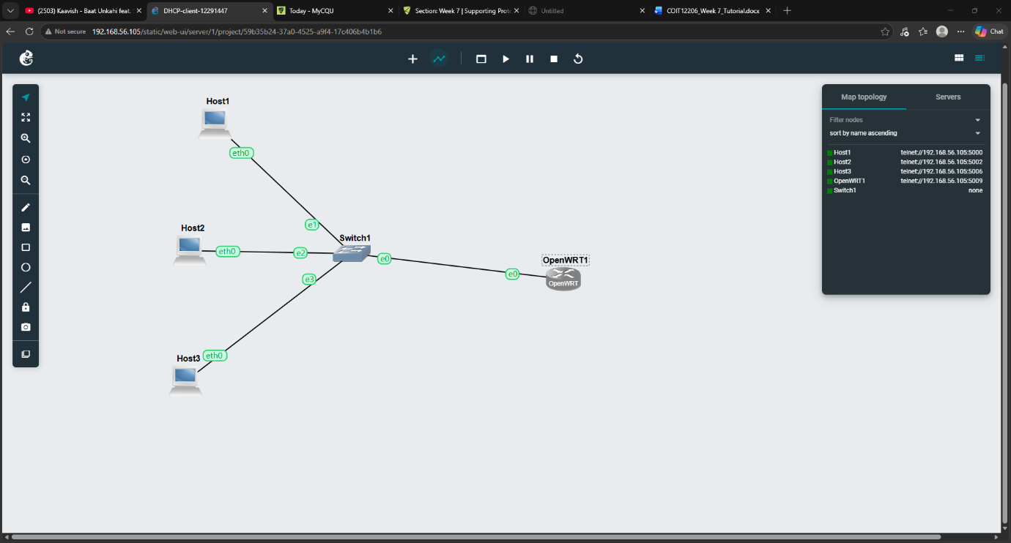

- After starting the openwrt1, in console its takes 2 mnst to reboot, after that I got this ip address onet 192.168.1.1/24
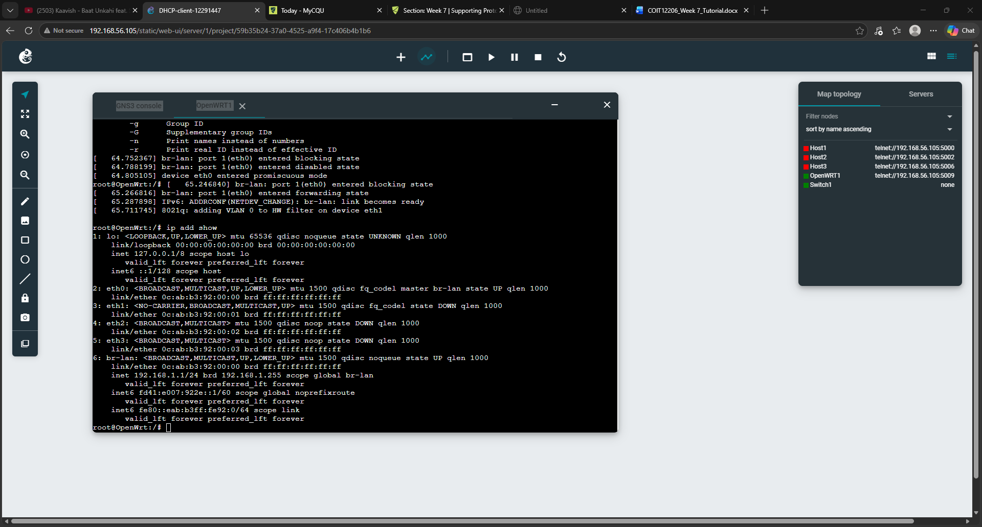

- Then started the host1,and there were no ip add as we didn’t assigned any ip address, then we run command udhcpc to assign a dynamic ip address in host 1. ( udhcpc is way to assign a dynamic ip address to a host automatically). After that we can see the ip for host one and the server is 192.168.1.1 which is the openwrt1 ip.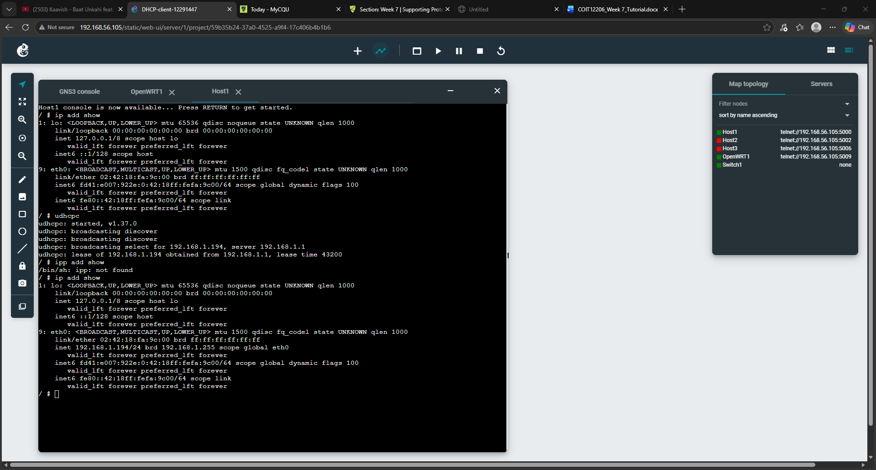

- In host 2, we are going to configure ip in another way, we are using nano /etc/network/interfaces command to assign a DHCP ip address here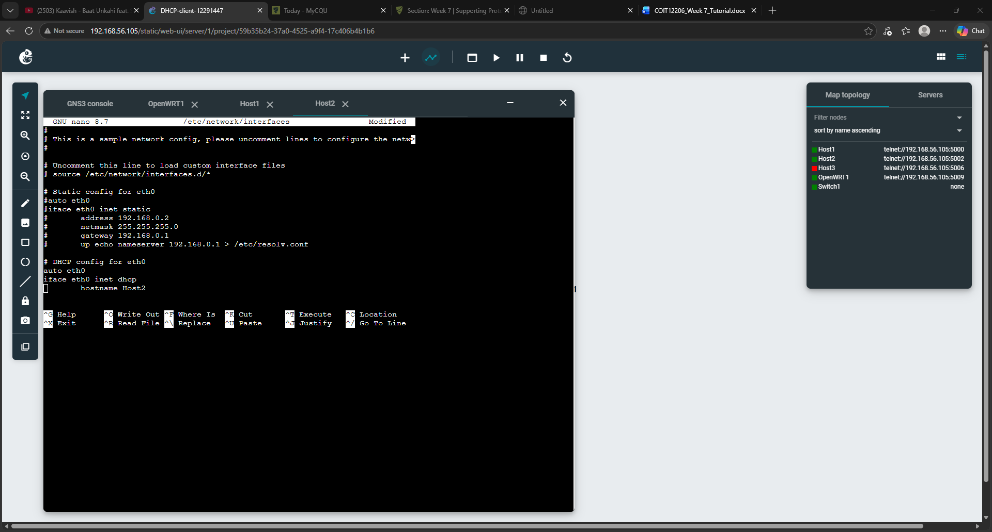

- After that here is the ip we get from host 2
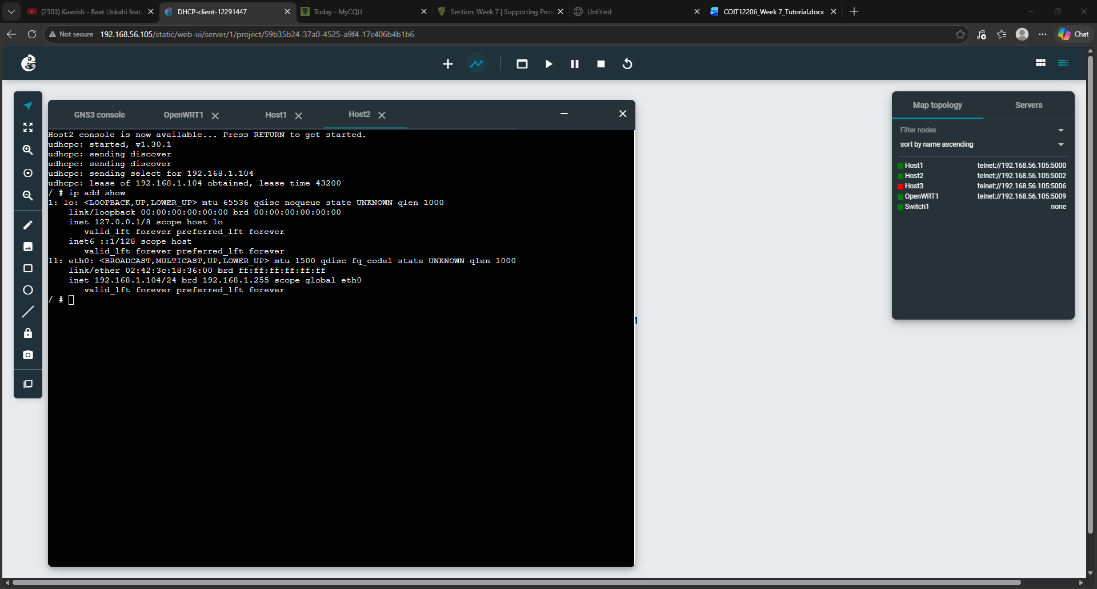

- For host 3, in the same udhcpc way, assigned ip and captured the file and save the file by filezilla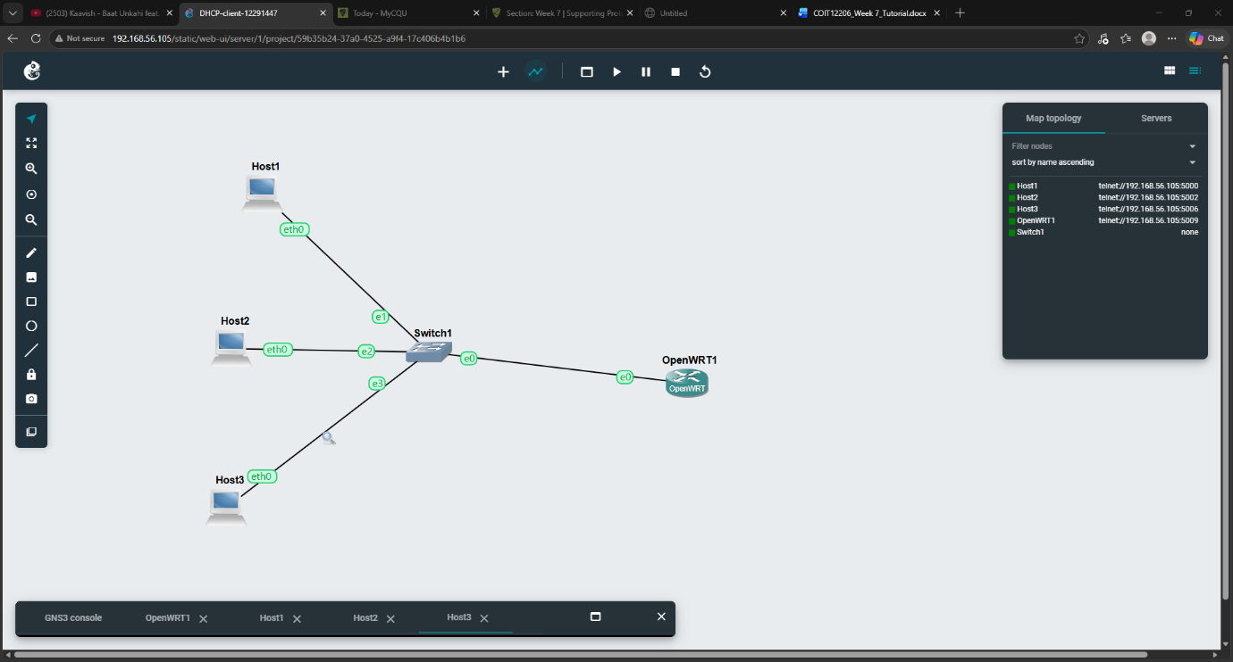
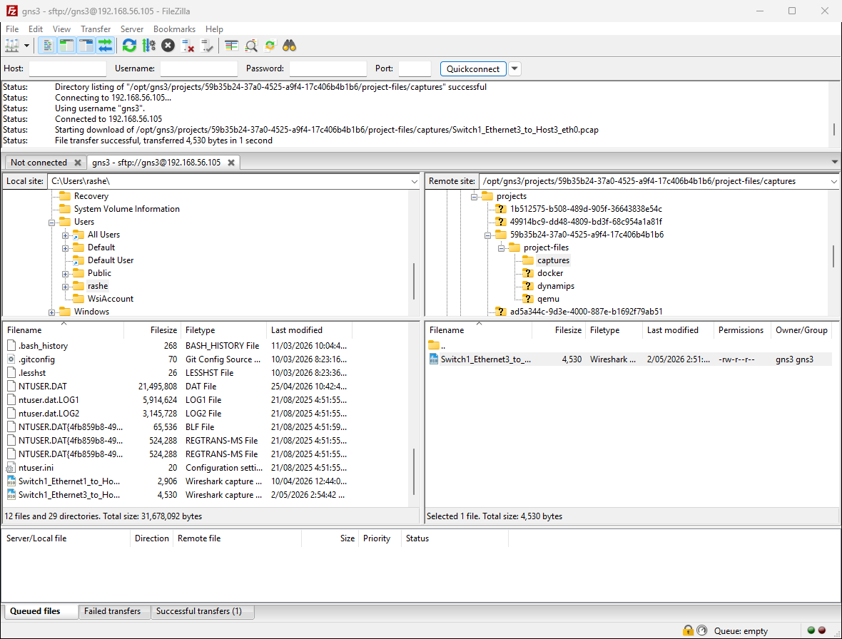

Task 2: DHCP Server Basics

- The configuration file for the DHCP (and DNS) server is called dhcp and can be viewed with: cat /etc/config/dhcp
- OpenWRT also includes a command called uci to view (show) values in a server configuration as well as change (set) values. You can use it to select certain parts of the configuration to show, e.g.: uci show dhcp.lan
- Usually a DHCP server maintains a list of current leases in a text file or database. On OpenWRT it is in the text file /etc/dhcp.leases. You can view it with: cat /etc/dhcp.leases
- You can also use uci to set values. There are multiple steps: 1. Set the value 2. Commit (save) the changes 3. Restart the server so the changes take effect.
For example, to change the DCHP default lease time to 2 hours:
uci set dhcp.lan.leasetime='2h'
uci commit dhcp
/etc/init.d/dnsmasq restart
- 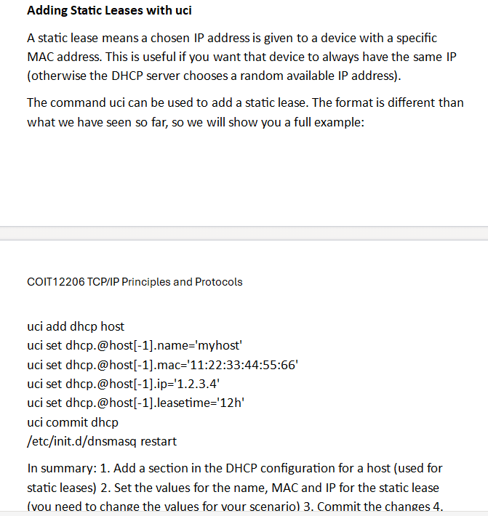

Task 3: Hosts File and Simple DNS Entries

- After having the ip for all, in host1, running command nano /etc/host to see the host information, we are putting host2 ip and fake domain name host2.example.com
 